Assignment 3

Elizabeth Dayton, Cole Beck, and Byeonghyeon Choi

HW/SW Requirements

This will be able to run on both a desktop computer (PC, Mac, etc.), any kind of tablet, and on a mobile device. The capabilities of the website would have to be slightly reduced for mobile so it’s user friendly. We would use some combination of HTML, CSS, and Javascript as well as Bootstrap to build this website.

Interface Metaphor and Interaction Type

For the interface metaphor, our website uses the logo of the Huntsville Police Department to let the user know as soon as they’ve opened up our website that they’re at the right place. Our website also uses the very familiar navigation bar that many other websites have.

For the interaction type, our website allows our users to explore some of the popular options through our navigation bar or to look at recent news on the front page. When an officer goes to our website, they click on employees to explore all of the resources they might need. Once at the appropriate form, they can manipulate the form and all of its fields and then submit.

Lexicon

Some common terminology needed to use the form includes but is not limited to:

* DPS, which means Department of Public Safety
* microfilm, which is a document that has been scaled down to about 4% of its original size
* control cirum(stance), which means circumstances that were out of human control
* Citation offense, which means that someone was charged on sight for a low-level crime instead of arrested and brought in
* Com veh, which is shorthand for commercial vehicle
* V.I.N., which means vehicle identification number

Use case/Scenario

Officer Bill is doing his routine night patrol on highway. He keeps his eye for vehicles that is parked on the side to see if they need help or not. While driving he come across a car with caution light on. Upon closer inspection he sees the car is crashed into the side. Officer Bill ask what happened and fills out the crash form

Officer Bill is doing a highway patrol during the hunting season. He come across a car that crashed with a wild deer that was crossing the road. Officer asses the crash site and fills out the form

Officer Bill is doing a city patrol. He come across a accident where driver hit a pedestrian, but ran away. He asks the pedestrian what happened and fill out the form according what the pedestrian said.

Office Bill is doing a highway patrol and comes across a crash site where one car rear ended another. He directs them to the safe place to park and fills out the crash form with information that is given by the people who are involved in the accident.

Persona

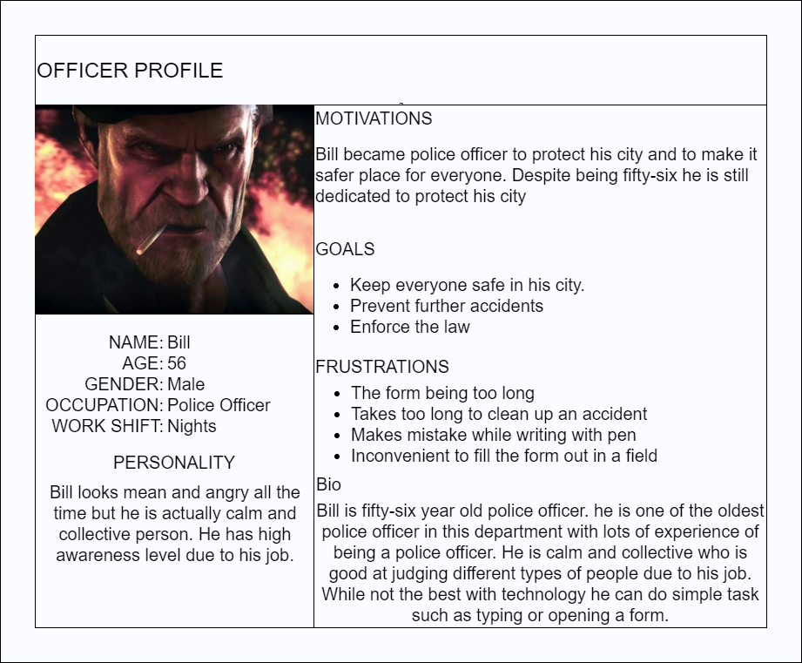

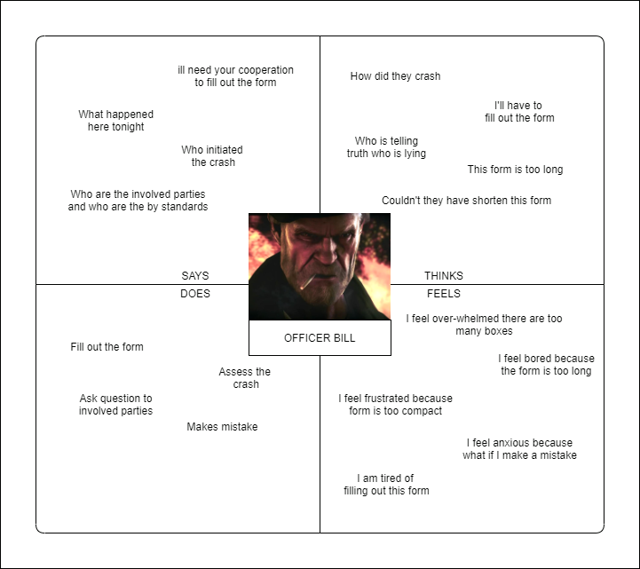Empathy Map

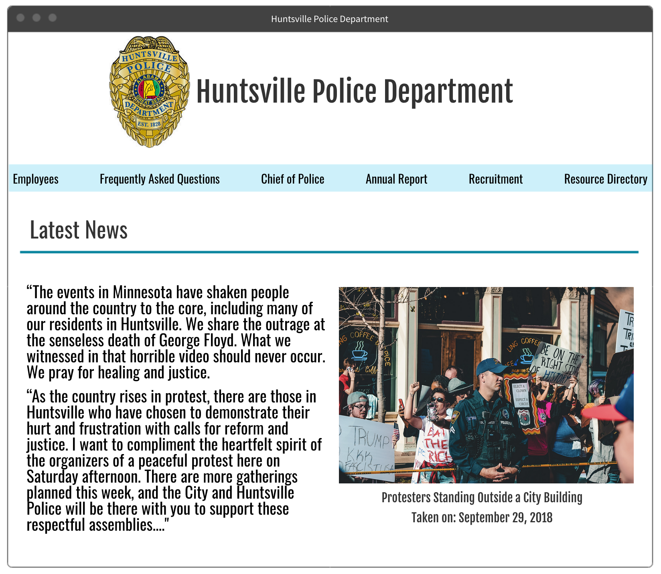Web Pages

